1. What does the %C&A metric measure in the Continuous Delivery Pipeline?

The percent concurrent and accurate process times of each pipeline activity

The percent of change averages of each pipeline activity

The percent of time downstream customers receive work that is usable as-is

The percent complete and average times of each pipeline activity

1. Which statement is true about DevOps?

It enables a tolerance for low-risk, low-failure, and rapid recovery

It enables high-risk releases and fast recovery with fast fix-forward

It enables low-risk releases and fast recovery with fast fix-forward

It enables low-risk releases and fast recovery with no room for errors

1. Why are canary releases used?

To reduce deployment times

To introduce minimum viable features

To allow incremental release

To prevent outages

1. Who should be consulted first when calculating the % Complete and Accurate?

The lead developer

Testers

End users

The people responsible for the next step

1. What is trunk-based development?

Every team works in their own trunk

All teams committing their code into one trunk

Each developer maintains a separate branch

Teams with similar dependencies create one single branch for the team's work

1. In what activity of Continuous Exploration are Features prioritized in the Program Backlog?

Research

Synthesize

Hypothesize

Finalize

1. What is the main goal of a SAFe DevOps transformation?

To implement an advanced tool chain to automate the entire Continuous Delivery Pipeline

To align people across the Value Stream to deliver value continuously

To create a strong DevOps team with leadership support

To create immutable infrastructure to avoid changes to the production environment

1. Who is responsible for building and continually improving the Continuous Delivery Pipeline?

System Teams

Scrum Teams

DevOps Teams

Agile Release Trains

1. What is the primary purpose of creating an automated test suite?

To increase the return on investment for finding defects

To enable continuous testing

To eliminate all manual testing

To increase unit test coverage during an Iteration

1. What does Culture in a CALMR approach mean?

A culture where developers code and operations deploys

A culture where technical expertise is paramount

A culture where development and operations report to the same manager

A culture of shared responsibility and risk tolerance

1. When preparing a DevOps backlog, prioritizing features using WSJF includes which two factors? (Choose two.)

Team velocity

Cost of delay

Duration/job size

Total count of items on the Program Backlog

Business value

1. Value stream mapping metrics include calculations of which three Metrics? (Choose three.)

Total Process Time

Outage Frequency

Activity Ratio

Rolled % Complete and Accurate

Release Frequency

Emergency Change %

1. One goal of DevOps in SAFe is to fully automate the steps between which two pipeline activities?

Code commit and release

Code commit and deploy

Code commit and stage

Code commit and user acceptance testing

1. What is the blue/green deployment pattern?

To decouple deployment from release

To deploy between an inactive and active environment

To deploy to only some data centers to reduce the deployment risk

To ensure no changes happen in production without going through the Continuous Delivery Pipeline

1. Which term describes the time it takes value to flow across the entire Value Stream?

Deployment frequency

Rolled percent complete and accurate

Total lead time

Activity ratio

1. What are two activities performed as part of defining the hypothesis in Continuous Exploration? (Choose two.)

Use innovation assessments

Identify Metrics based on leading indicators

Use value stream mapping

Define the minimum viable product

Elicit feedback

1. Which statement describes the Lean startup lifecycle?

Define the minimum viable product (MVP), build the MVP, implement Epic Features until all Features are delivered

Create a hypothesis statement, assign an Epic owner, deliver Features created from the Lean business case, deploy

Define a Lean business case, build a minimum viable product, implement the Epic Features until all Features are delivered

Define the hypothesis, build a minimum viable product (MVP), continuously evaluate the MVP while implementing additional Features until WSJF determines work can stop

1. What is the primary benefit of value stream mapping?

It fosters collaboration among development and operations managers

It identifies how to build Agile Release Trains

It creates the hypothesis of which Solution to build

It provides insight into organizational efficiency and value flow

1. Which two security skills are part of the Continuous Integration aspect? (Choose two.)

Penetration testing

SOX compliance analysis

Application security

Security board review

Network security practices

1. What are the first two actions for visualizing the current state of the Continuous Delivery Pipeline? (Choose two.)

Identify lead time

Identify the people

Identify the development methodology

Identify throughput

Identify the steps

1. The Release on Demand aspect enables which key business objective?

Business value

Alignment

Quality

Time-to-market

1. Which technical practice is key to enabling trunk-based development?

Refactoring

Feature branching

Code freezes

Gated commits

1. What is the purpose of a minimum viable product?

To sell to new markets

To demo to Product Management for feedback

To release to production

To validate the hypothesis

1. Which DevOps principle focuses on identifying and eliminating bottlenecks in the Continuous Delivery Pipeline?

Recovery

Automation

Measurement

Lean flow

1. What are two aspects of the Continuous Delivery Pipeline, in addition to Continuous Integration? (Choose two.)

Continuous Testing

Continuous Release

Continuous Deployment

Continuous Improvement

Continuous Exploration

1. What is a core DevOps principle?

Servant leadership

Culture

Lean Budgets

Iteration review

1. Which two technical practices focus on Built-in Quality? (Choose two.)

Environment configuration

Canary releases

Pair work

Test-driven development

Feature toggles

1. What is one recommended way to architect for operations?

Establish an architecture review board

Implement feature toggles

Create detailed run books

Require developers to support their own code

1. What falls outside the scope of the Stabilize activity?

Failover and recovery processes are in place

Continuous security monitoring is done

Features are monitored after release

Blue/green deployment

1. Who is responsible for ensuring quality is built into the code in SAFe?

Agile Teams

Testers

Developers

Product Owners

1. Which practice prevents configuration drift between production and non-production environments?

Immutable infrastructure

Deployment automation

Session replay

Self-service deployment

1. What is the desired frequency of deployment in SAFe?

Once per PI

Daily

Once per Iteration

Continuous

1. Which skill can significantly accelerate mean-time-to-restore by enabling support teams to see issues the way actual end users did?

Session replay

Incident management

Page analytics

Blue/green deployment

1. What is the correct order of activities in the Continuous Integration aspect?

Develop, Build, Test end-to-end, Stage

Develop, Test end-to-end, Build, Stage

Stage, Develop, Build, Test end-to-end

Build, Develop, Stage, Test end-to-end

1. Why is it important to take a structured approach to analyze problems in the delivery pipeline?

It allows the solution to be demoed to key stakeholders

It provides a structured roadmap for the SAFe implementation

It helps ensure that actual causes of problems are addressed, rather than symptoms

It ensures that solutions are more likely to be approved for implementation

1. Which statement describes a measurable benefit of adopting DevOps practices and principles?

It guarantees an increase in profits and decrease in downtime

It creates a highly functional, cross-team culture

It results in faster lead time, and more frequent deployments

It identifies key Value Streams

1. DevOps is a key enabler of continuous delivery. What does continuous mean in this context?

To deploy to production and release at least once every Program increment

To deploy to production as often as possible and release when the business needs it

To deploy to production multiple times per year and release on a cadence once or twice a year

To deploy to production and release on cadence every Iteration

1. Value flows through which aspect in the Continuous Delivery Pipeline?

Continuous Integration

Research

Develop

Monitor

1. What are two important items to monitor in production to support the Release on Demand aspect in SAFe? (Choose two.)

Business value

Time-to-market

Lead time to defect fixing

Deployment lead time

System performance

1. Innovation accounting stresses the importance of avoiding what?

Vanity metrics

ROI calculations

Quantitative metrics

Objective metrics

1. Mapping the value stream helps accomplish which two actions? (Choose two.)

To add or remove user segments based on business decisions

To gain insight into organizational efficiency

To serve as a blueprint for development

To understand how the flow of value can be improved

To prioritize the Program Backlog

1. What are two benefits of DevOps? (Choose two.)

Less frequent deployments

Less time spent on new work

More lead time

Less time spent fixing security issues

Fewer defects

1. What is the primary goal of the Stabilize activity?

To avoid unplanned outages and security breaches

To achieve active-active site replication

To establish quality-of-service agreements with customers

To enhance stability with blue/green deployment

1. Which two areas should be monitored in the Release on Demand aspect to support DevOps and Continuous Delivery? (Choose two.)

Deployment cycle time

Business Metrics

Full-stack system behavior

Agile Release Train velocity

Build status

**After the team maps the steps of the current state Value Stream during value stream mapping, what are the next two steps? (Choose two.)**

Identify who is involved in each step of the delivery pipeline

Measure the performance at each step

Perform a SWOT analysis

Discuss the current state and perform an improvement analysis

Identify bottlenecks in the delivery pipeline

Amit’s sample questions:

1. Feature toggles are useful for which activity.
2. Which two skills appear under the respond sub-dimention
3. Which technical practice incorporates build
4. What are the first two areas
5. What are the top two advantages of mapping
6. Which activity is performed in the Build
7. What differentiates deployment and release in
8. Which statement describes what could happen
9. Security vulnerability scanning is an important
10. Ensure that security controls such as threat modeling
11. Gemba walks are an important competency in support of which sub-dimension
12. What marks the beginning of the continuous delivery pipeline
13. When should teams use root cause analysis
14. Where do features go after continuous exploration
15. What is an output of the release sub-dimension
16. When full deployment automation is not possible, which practice helps developers deploy
17. What does value stream mapping help reveal
18. Which two statement describe the purpose of the value stream
19. Which matric reflects the quality of output
20. Continuous deployment enables which key
21. What can impede the progress of a
22. What should be measured in a CALM
23. The explore dimension primarily supports
24. What is the recommended way to prioritize
25. What does the activity ratio measure in the value stream.
26. What is a consequence of worker in isolation
27. What should the team be able to do after
28. A canary release involves releasing
29. How is lean UX used in continuous
30. The Devops radar aligns the dimension
31. When does the continuous integration
32. What identifies potential changes to the current
33. What is one potential outcome of the verify
34. How should developers integrate refactoring
35. Why is hypothesis evaluation important
36. What are two benefits of devops
37. What are two reasons for test
38. Which incident response practice most strongly suggested
39. What triggers the release activities?
40. Which is the true about the “boundaries and Limitations”
41. Weighted shortest job first is applied to backlogs to identify what
42. What are two part of the continuous delivery pipeline
43. What organizational anti-Parten
44. Which statement illustrates the biggest
45. What steps in the value stream
46. What is meant by CALMR
47. What is the primary purpose of mapping
48. What is lead time for an activity
49. What is process time for an
50. Total process time divided by
51. Identifying the minimum
52. What is the final step in the
53. What is the main intent behind
54. How frequently should
55. What is measured in each step of the value stream

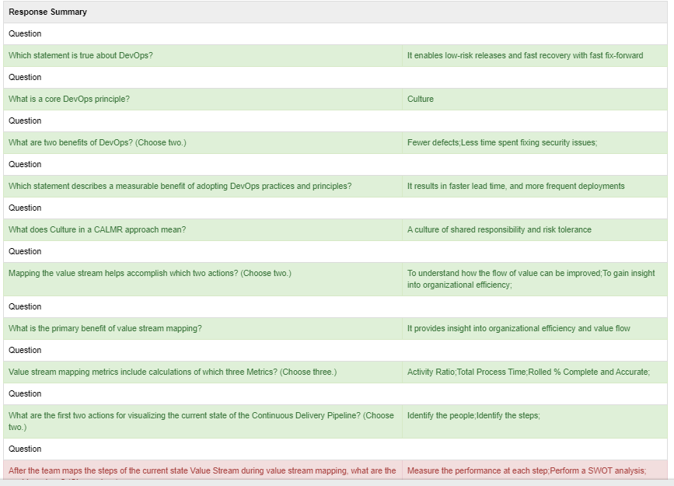 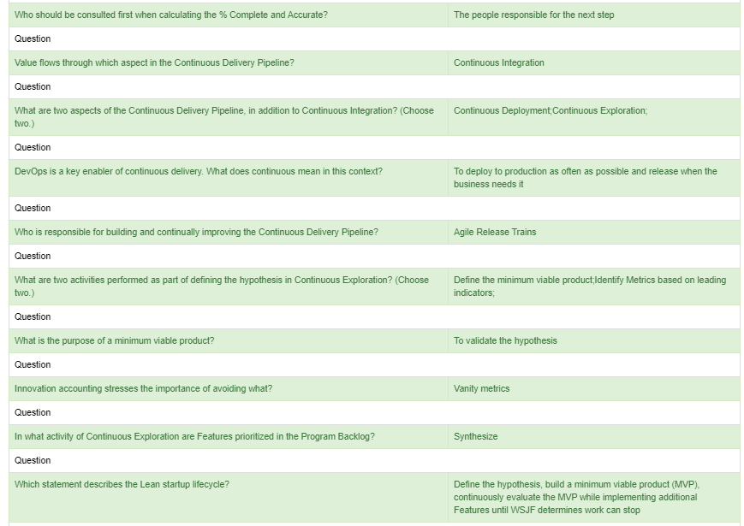 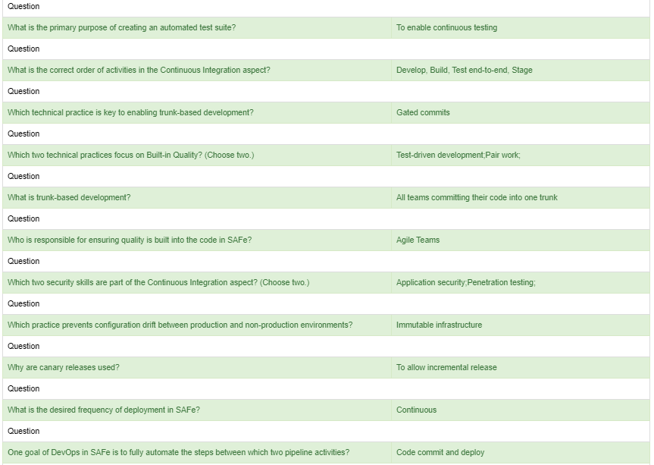 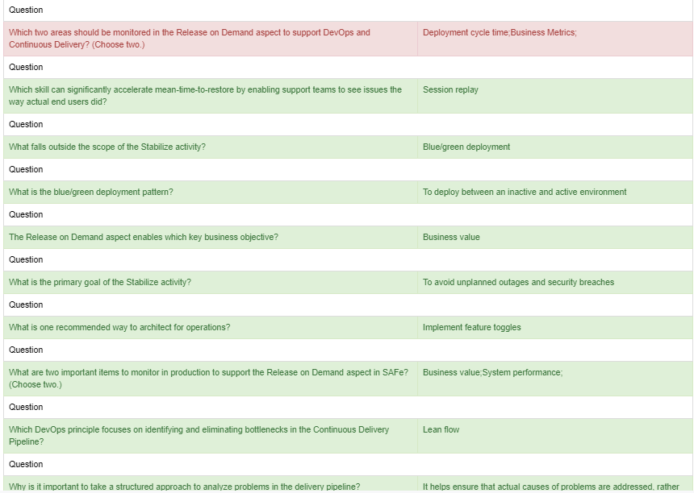 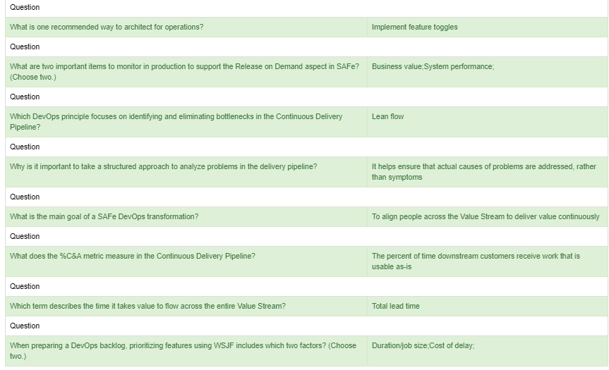

**What work is performed in the Build activity of the Continuous Delivery Pipeline?**

Code review

Compile

Code

Automated acceptance testing

**Which steps in the Value Stream should be the main focus when prioritizing improvement items?**

Steps with long lead time and short process time in the current-state map

Steps with short process time and short lead time in the future-state map

Steps with a high activity ratio

Steps with a long process time

**Which is true about the Boundaries and Limitations portion of the DevOps Transformation Canvas?**

It captures the people who need to be involved in the DevOps transformation

It captures cultural constraints that will prevent us from ever moving forward

It captures actions that require the support of other people or teams

It captures lower priority improvement items

**The Continuous Exploration aspect primarily supports which key stakeholder objective?**

Research and development

Business value

Hypothesize

Alignment